Shiloh United Methodist Church

John 1:1, 14, Rev. Tyler Amundson November 22, 2020
Psalm 19:14
In the Beginning was the Word

It is interesting and fascinating how certain words, at the right moment can cement in our minds and change our lives. One such event happened with one of my beloved college professors. A wise man who could be caught behind the building after class smoking a cigarette in his regular attire of jeans, vest and fedora. We were sitting in a class, on rhetoric, how to persuade people with words, and he said, “If you even do a Eulogy, remembering of someone’s of life, don’t ever say anything untrue.”

Since that day I have done more funerals and memorials than I knew I would do at that moment. Those words were worth more than my professor will ever know. I have helped remember some of the most amazing, kind, and gentle people. And I have offered words for, how does George Lucas write about them in Star Wars, oh yeah, “Scoundrels.”

Never to my knowledge have I said something untrue, and somehow in that simple rule…each of those services carried the meaning the families needed to step through their grief and continue their journey. We have laughed at the scoundrels shenanigans, and cried for our heroes. The knowledge my fedora wearing, smoking professor shared with me that day, was not deeply moving or profound. However, the truth held in those words have cleared simple paths for me, in complex and emotionally mined situations.

My professor knew then what I was going to learn later, our words matter and they have to power to help people build up the world, or false words can create a shaky foundation and people will later see things fall apart.

I asked friends and family online to share words that lifted them up. Many people posted after that prompt. There were lessons from fathers and mothers, gentle phrases from wise teachers, and deep words from wise adopted grandmothers met along the way. The deep truths that struck me was, how small groupings of words continue to shift peoples’ entire existence. That in the moment of death, both sinner and saint alike are the same. And in that moment you realize simple words can be the very water of life described in scripture.

This truth is found in short pithy phrases and pictures we find on social media, called memes are so hilarious when they align with our truths or destructive when they highlight something that hurts us. Let me show you an example.

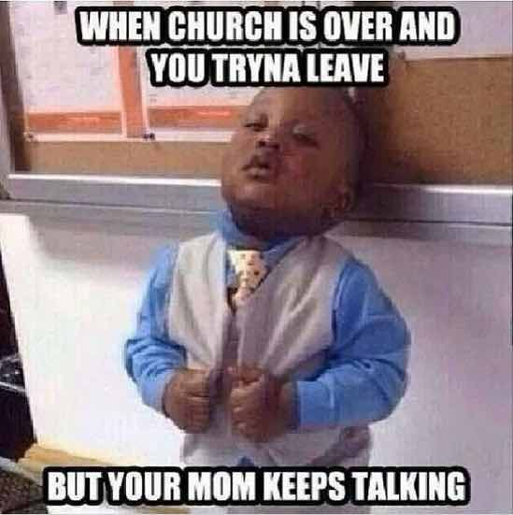

This little boys look and these words describe a situation we can tease out. Now these words are funny to us mostly, but words like this might also sting if you enjoy that time after church when you get to see each other or you miss it this year especially.

The other thing I heard from people is that there were words from a parent, friend, teacher, pastor, or someone meaningful in their life that also stung. Words painful enough to remember 20 or 30 years later. We all know these words that tear us down when we look in the mirror, or eat at our hearts when we should be experiencing grace. These are the words that cause stress, pain, and feelings we would rather numb out to rise in us again.

So, we have spent the last 4 weeks studying words. And even though we have heard about sticks, stones and words like it was biblically based and factual truth. Words can hurt and tear down.

If words are so volatile, then why did early Christians choose a Word to describe our the very source of life they believed God had sent to us?

Before I go any further I am going to invite us to recite the scripture we have been saying all throughout this series, and many of us have prayed over each week. This is written on a card, along with other resources for this series you can download from www.ShilohBillings.Church/worship. Please join me in reading from Ephesians.

Ephesians 4:29:
Let no evil talk come out of your mouths, but only what is useful for building up, as there is need, so that your words may give grace to those who hear.
Let’s also flip over the card to this passage from Psalms in the Hebrew Bible:
Let the words of my mouth and the meditation of my heart be acceptable to you, O Lord, my rock and my redeemer. Psalm 19:14

A beautiful metaphor came across my desk as I was working this past week. It was from a man named Parker Palmer, who has taken Quaker principles and applied them, so that others might step away from the divided life and find the full life Jesus is about.

Parker Palmer describes a scenario that happens in the American Great Plains each fall. Farmer’s that live in the places where blizzards can hit without warning, tie a rope from their back door to the barn. To watch it without context would seem strange. However, with the proper context this invention is designed to save a life.

You see in a white out blizzard, when the winds are blowing and the temperature has dropped. It is incredibly easy to lose your direction in this kind of storm. Many families have lost a loved one who was close to home, but just wandered and finally gave up. This rope helps them get from the barn back to their home, even when the world’s storms are swirling around them.

I shared this story with a group last week and low and behold someone knew a friend who had died, when they lost their way between the barn and home.

Words that build up, faith words, are a lifeline in the storms of this world. A simple phrase can draw us back on course for home.

There is a name for God that appears over 6,000 times in the Hebrew Bible, our Old Testament. It actually has no direct pronunciation, because no one in the modern day really knows how to say it. Transliterated it comes out to the English letter YHWH. You may have hear people say it in church, Yahweh.

The sound we think YHWH makes it sound like the wind. It was such a sacred word for the ancient Israelites that they would not say it except in specific temple rituals, and only certain people knew how to say it. The commandment from the Ten Commandments given in tradition to Moses, “Thou shalt take the name of our God in vain,” stems from this idea. For some modern day orthodox Jews it is still thought you should bury anything with God written on it in the ground if you are getting rid of it. For God’s name is alive.

Moses in the burning bush episode, hears the phrase “I AM” when he asks God’s name, making it timeless.

And our forebearers in the faith chose in the Greek the following way to describe this same reality.

John 1:1

Common English Bible

Story of the Word
1 In the beginning was the Word
and the Word was with God
and the Word was God.

John 1:14

Common English Bible
¹⁴ The Word became flesh
and made his home among us.
We have seen his glory,
glory like that of a father’s only son,
full of grace and truth.

What all of these words, what the phrase “The Word” means to us is that words have the ability to build us up in ways we have yet to even imagine. So, our words matter. They matter to other people, to creation and yes God does care about our words.

I never could for the life of me why God would care about the third commandment, the way it was taught to me growing up. I would say, “Oh my God,” about some thing that blew my mind and people would say, “Shhh….don’t take God’s name in vain.” I would think, “God doesn’t want me to say his name? Isn’t that what people do in prayer each Sunday?” The power of words tells us, that instead what our recent forebearers were worried about is the meaning of the word changing, to be something that was not used to describe the sacred. It is why for the Jewish community before us, and for the Christian community the sense of reverence was bestowed on the Word. God is timeless, spanning the generations, and is isness in a way we can’t imagine.

Our ancestors wanted to convey that God in Word could be a lifeline to us in the storms of this world for us to hold on to as we found our way home.

And God has been, for travelers, lost souls, addicts, people in pain, those seeking peace, and those who build bridges.

Our role in the story of God moving ahead is to find ways to use our words to transform our world, by listening to God, sharing God’s word, and letting ourselves be a part of securing the lifeline for others to come. In hopes that we can all find our way home.

The Word made flesh, the I Am has done this for slaves made kings and banished to be shepherds, for lowly fishermen, for women at the well, and for Queens who saved their people.
Let’s read again from the Psalm for today:

Let the words of my mouth and the meditation of my heart be acceptable to you, O Lord, my rock and my redeemer. Psalm 19:14

As you go from here, how will you use your words to join The Word of Life in transforming the world?

Shalom and Amen

